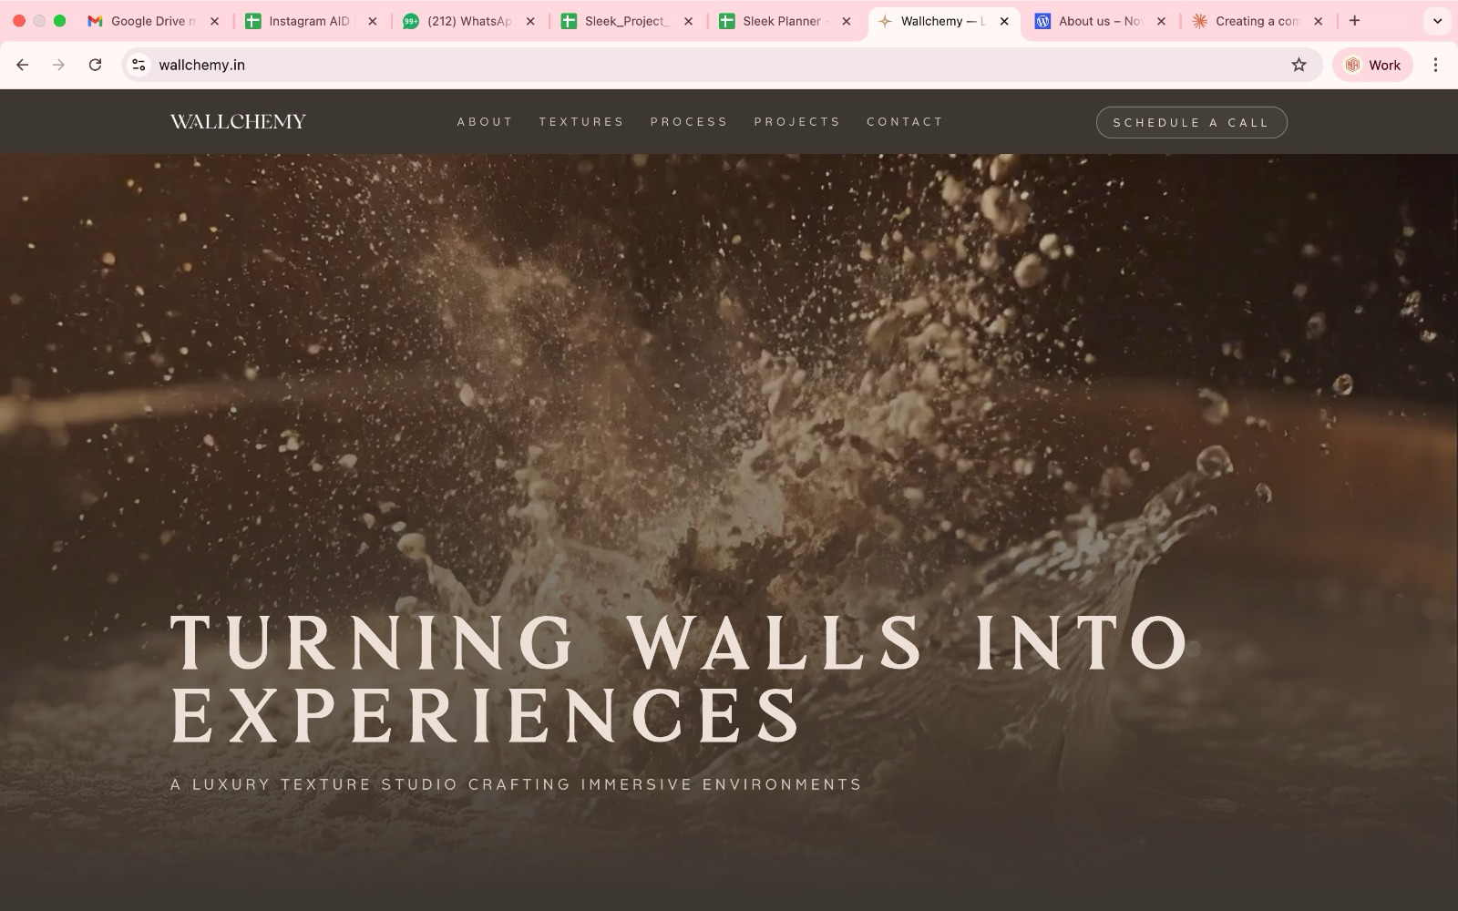
1)this video hasnt played in the last few days everytime I've landed on the page - pls see

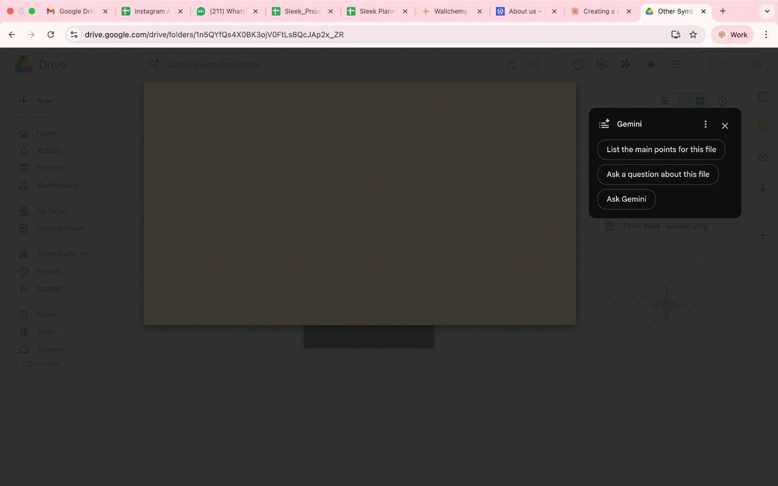
2) I want the main bg to be the monogram bg dhanraj designed in brown; the monogram should be slightly visible

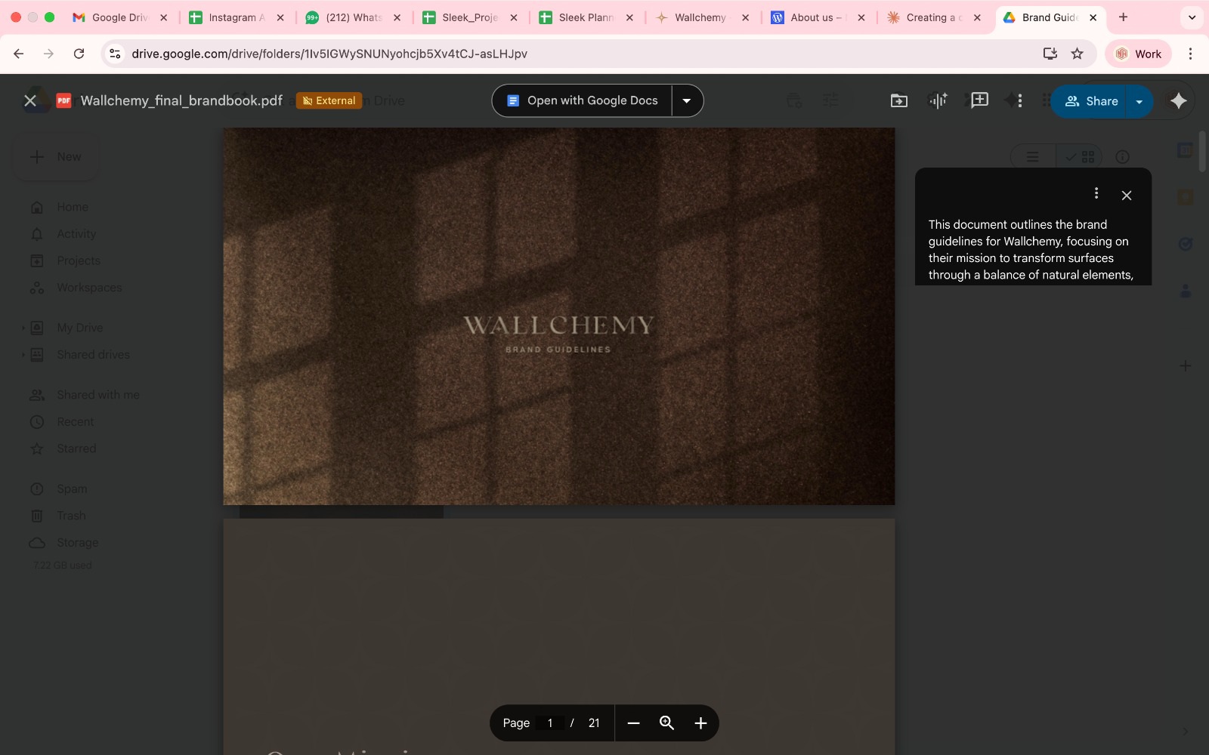
3) I;d like to see this gold logo on the brown bg overlay on the top tile of the website, currently it's white

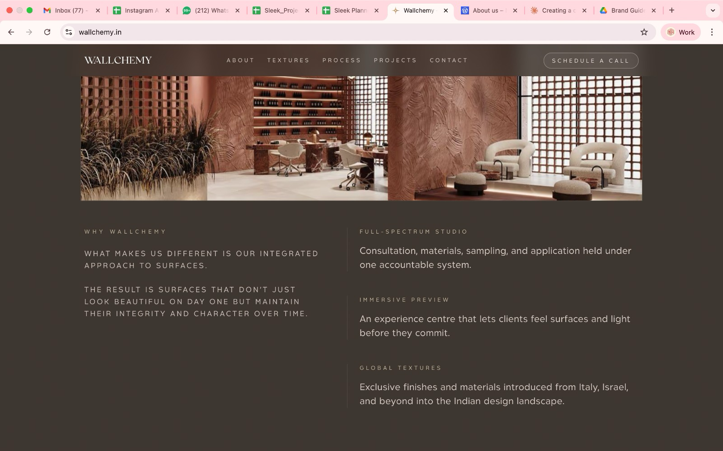
reading too verbose, can we make the headings bolder and larger, main body can be slightly smaller - open to your aesthetic opinion on it

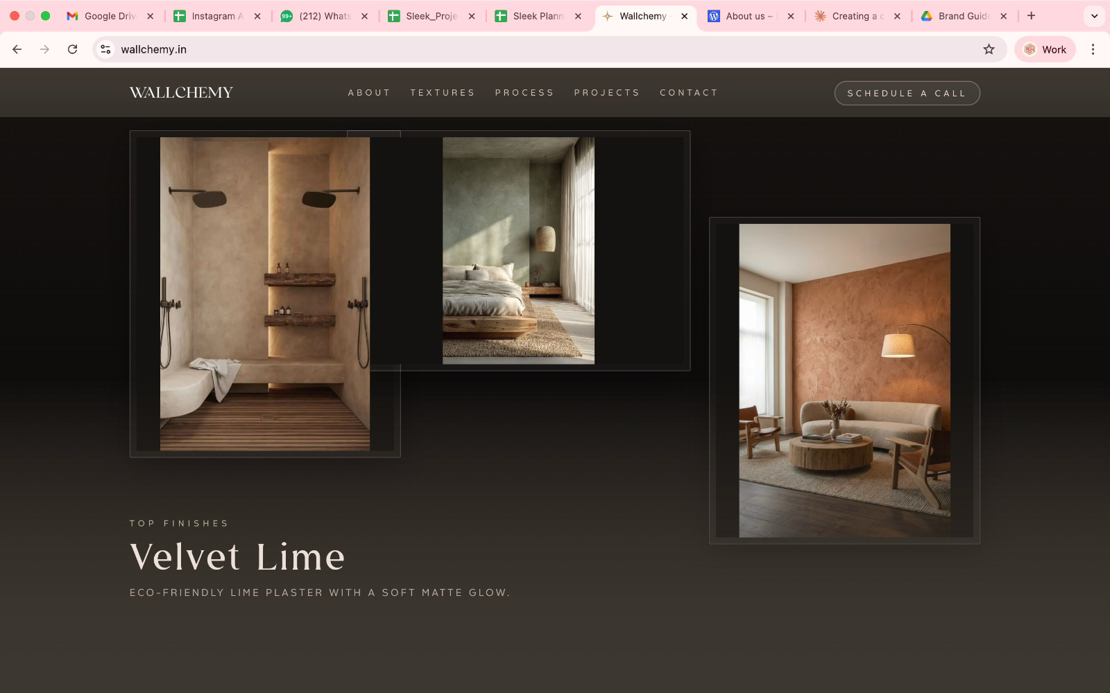

this tile set up I dont like, please design some thing that’s creative

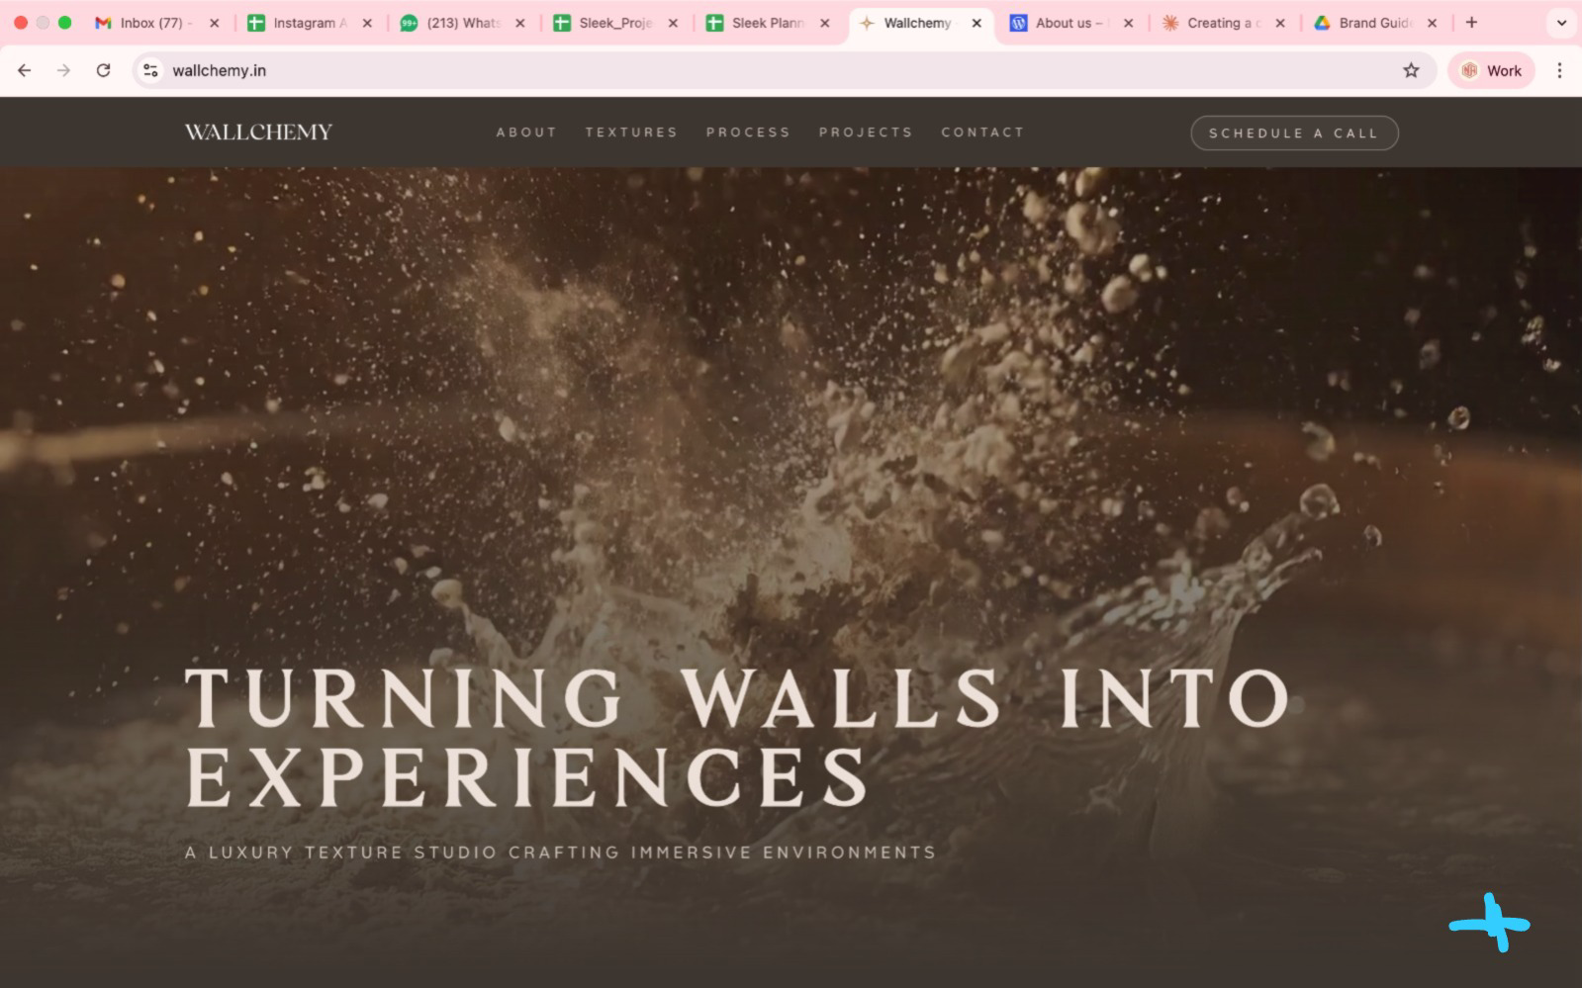

can we have the wallchemy star at the bottom (fixed)

https://steven.com/
i'd like the website to begin like this, a play with the logo which then launches this landing page

